**Project 6 Coin Detection – Part 1 – voting for centers**

Name: Vivian Feng Period: 5 Date: 2/1/2023

Did you name your file l061.cpp (Lower case L, then 061)? Yes

Did you create the edge matrix? Yes

Did you create the gradient direction matrix? Yes

Did you create the imagev.ppm (visual of votes)? Yes

Did you use Bresenham's line algorithm for voting? Yes

Did you test on the terminal/jupyterhub? Yes

Below for the easy image provided paste the imagev.ppm, imageCC.ppm you obtained running your code:

What are the 3 values you sed for lower/upper thresholds and also for the threshold for votes:

* Low threshold = 75
* High threshold = 100
* Threshold for votes = 25
* Optimizations: Bounding box when voting, keeping only the top 10% of center candidates within a kernel box of size 11

imagev.ppm:

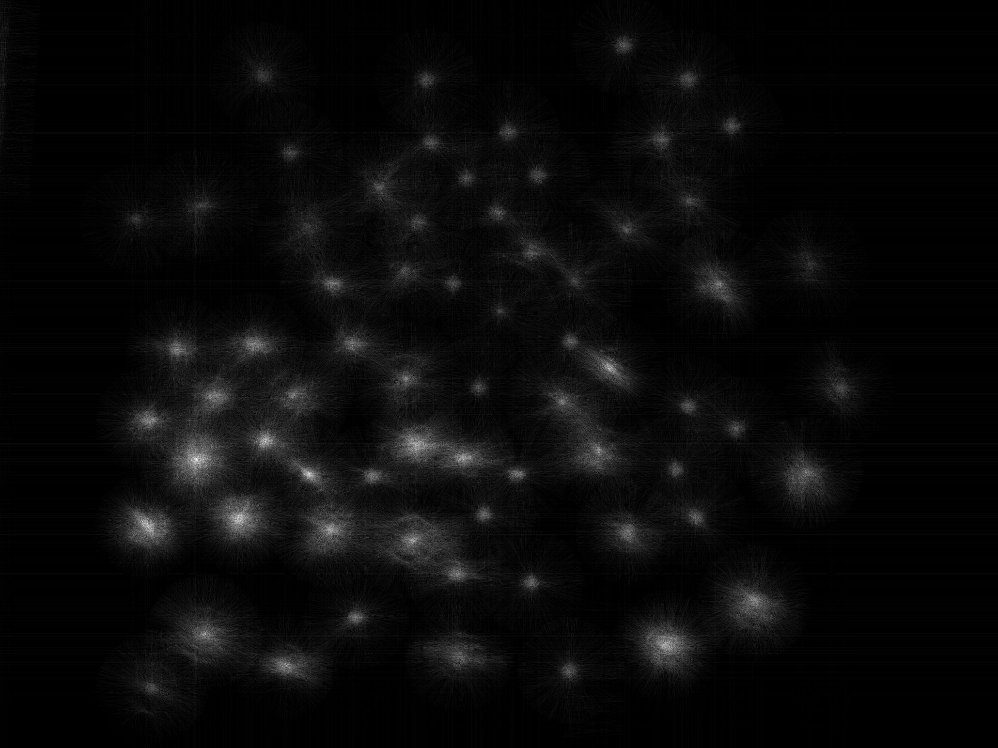

imageCC.ppm:

